

**Project Documentation**

**for**

A Web Collaboration Tool for Students

**by**

**Colm Doggett – B00106947**

**Jakub Plich – B00098516**

**Nikita Savkovs – B00101929**

***Submitted in partial fulfilment for the Major Group Project Module for the Bachelor of Science (Honours) in Computing in the***

***School of Computing***

***Department of Informatics and Engineering***

***December 2019***

Table of Contents

Design 1

Architecture Diagram 1

Use Case Diagrams 2

Login System 2

Logout System 2

PDF Upload System 3

Registration System 3

Activity Diagrams 4

Login 4

Logout 4

Class Diagrams 5

Controllers 5

Entities 7

Repositories 9

Project Progress: Work Carried Out 14

Project Progress: Work to Be Carried Out 15

Appendix 16

Project Gantt Chart 16

# Design

## Architecture Diagram

Below is a high-level overview of the project’s architecture. The front-end will be sending AJAX requests to the back-end, which will act as an intermediary between front-end and a database. As can be seen, in the initial design, front-end and back-end are completely separated, with front-end sending requests to the back-end when specific database manipulations are required.

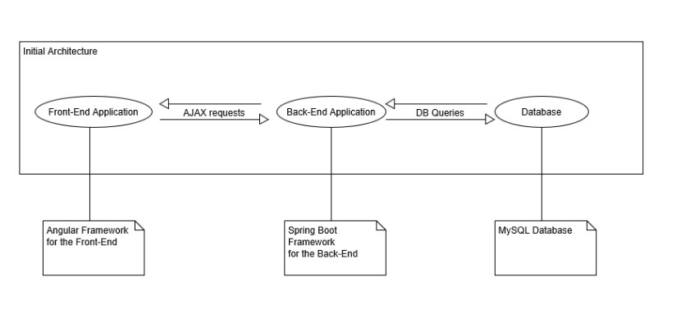

Figure . Initial Architecture Diagram

## Use Case Diagrams

### Login System

### Logout System

### PDF Upload System

### Registration System

## Activity Diagrams

### Login

### Logout

## Class Diagrams

### Controllers

**Login Controller**

**Query Controller**

**User Controller**

**User Profile Controller**

### Entities

**User**

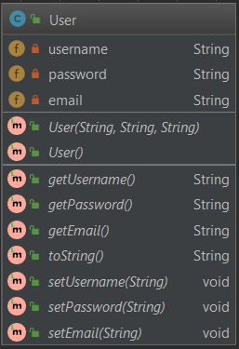

**Profile**

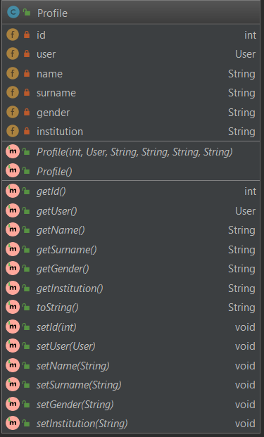**Query**

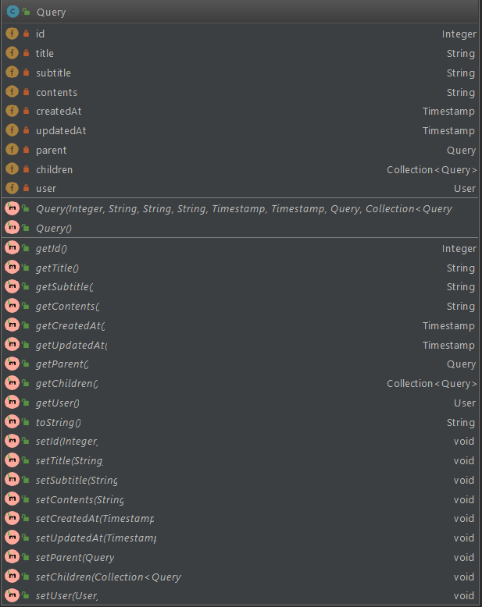

### Repositories

**User Repository**

**User Profile Repository**

**Query Repository**

**Services**

**User Service**

**User Profile Service**

**Login Service**

**Query Service**

## Project Progress: Work Carried Out

The team has carried out a research into the main technologies that will be used for the implementation itself – Spring Boot and Angular, as well as research into Software Development Life Cycle methodology that the team is using, which is Agile, as well as Scrum. In addition, even though no actual implementation yet exists, a preliminary research was carried out into:

* PDF extraction using the PDFBox, OCR using Tess4J which is used with conjunction with PDFBox and a working prototype is currently being implemented.
* Data mining using Mallets topic modelling, which uses LDA.

The additional project-related work that was carried out includes writing up the documentation, creating and delivering presentations and creation of a poster for the project.

Regarding actual implementation, the following work has been carried out:

* Creation of login and sign-up pages on the front-end, with the related functionality being implemented in the back end as well (Nikita and Colm).
* Creation of user page (preview) and user settings page (permits to change account information and profile information, privacy settings are added but do not perform actual work as of yet), with the related functionality being implemented in the back-end as well (Nikita and Colm).
* Creation of a preview versions of the public forum related pages, such as query browsing and creation and query page itself (Nikita).

Regarding research and project documentation, the following work has been carried out:

* Colm’s and Nikita’s project proposals were merged (Colm and Nikita, with Nikita merging the main bulk of the proposals and Colm editing and proofreading, as well as adding additional sections on research and system requirements).
* Project documentation has been written up (Colm and Nikita, with Colm writing up, proofreading and adding relevant diagrams and minor contributions from Nikita).
* System use cases created (Colm).
* Class diagrams reflecting the current state of the system created (Colm).
* Presentations were prepared (Colm and Nikita).

In regard to additional tasks related to the project, the following work has been carried out:

* Creation of a GitHub repository (Nikita) – URL: <http://github.com/TherionXII/MajorGroupProject>
* Creation of a Kanban board on Trello (Nikita).
* Completion of tutorials on Angular and Spring Boot (Colm).
* Code maintenance and refactoring (Nikita).
* Kanban board management (Nikita).

## Project Progress: Work to Be Carried Out

As of this writing, the team is staying slightly ahead of the schedule, with the first major part of the project implemented – user creation and user account management, and with parts of the second major part of the project – query creation and management – being approximately sixty percent finished. The parts of the system that are yet to be completed as to conform to the aims and objectives outlined in the project proposal are:

* Implementation of the query-related functionality (create, rate, display, reply).
* Implementation of the PDF extraction functionality (upload, check, store).
* Implementation of the private collaboration features (private groups, chat, real-time collaboration).
* Implementation of the different privacy settings for user profiles and user queries.

The parts of the system the team is currently working on are:

* Implementation of a working PDF-extraction prototype (using both PDFBox and OCR) – Colm.
* Finishing the implementation of the query-related functionality – Nikita.

In addition, the team has outlined a couple of possible improvements that can be made to the application as a whole in the project proposal; those shall be implemented should the team have enough time; based on the current schedule and progress, it is thus possible to conclude that the following functionality is likely to be implemented as well:

* User profile and query moderation and administration.
* Partial or full cloud migration.

# Appendix

## Project Gantt Chart

Figure Proposed timeline for Project